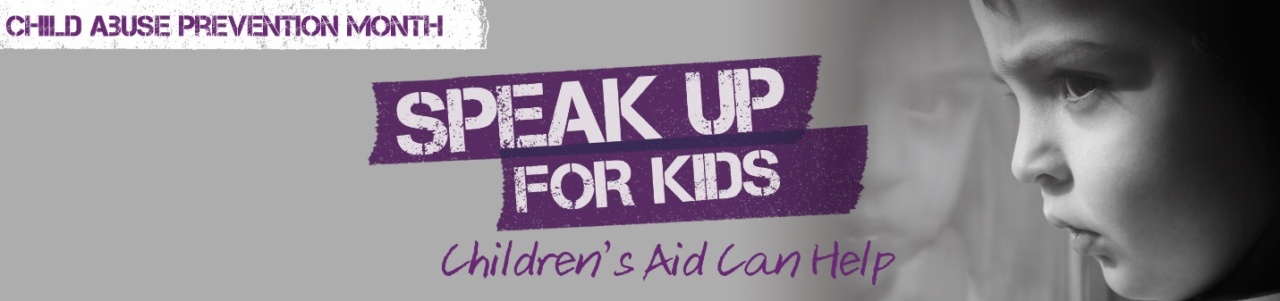
Key Messages – Dress Purple Day

General
- October is Child Abuse Prevention Month. Communities, boards of education, and schools across Ontario will Dress Purple on Tuesday, October 24, 2017 to collectively speak up and share the message that child abuse and neglect can be prevented and that help is available.
- The tag line for Dress Purple Day is “It takes a village to keep kids safe.” The social media hashtag for Dress Purple Day is #IBREAKthesilence.

Dress Purple Day Classroom Resources – Boards of Education, Schools, Teachers, Parents
- The Ontario Association of Children’s Aid Societies (OACAS) has worked with Boost Child & Youth Advocacy Centre and Windsor-Essex Children’s Aid Society to develop the Dress Purple Classroom Resources. These materials have been developed in response to feedback from boards of education, schools, and teachers looking for more detailed messaging to provide their students during Child Abuse Prevention Month (CAPM) and Dress Purple Day.
- Dress Purple Day Classroom Resources have also been developed to support key recommendations from the Inquests into the deaths of Jeffrey Baldwin and Katelynn Sampson. Inquest recommendations included the need to develop age appropriate curriculum for students about child abuse and neglect, to raise awareness about duty to report with school staff and the public, and to support collaborative projects between CASs and Boards of Education.
- This year, Dress Purple Classroom Resources are directed at students in junior kindergarten to grade five classes, with the goal of expanding support to middle and high school grades next year.
- The purpose of Dress Purple Classroom Resources is to assist teachers to talk about child abuse and neglect in an age appropriate manner and to help raise awareness among children about how to ask for help from adults in the community. Ensuring that children are aware of helping adults in their support network offers an important prevention tool for children and youth.
- The classroom resources are built around the theme “It takes a village to keep kids safe.” The Dress Purple Day Classroom Resources are divided into four lessons:
- “It Takes a Village to Keep Kids Safe,”
- “Safety in the Village,”
- “Well-being in the Village,” and
- “Dress Purple Day: #IBREAKthesilence”
- Dress Purple Classroom Resources are available in English at this link.
- Dress Purple Classroom Resources are available in French at this link.
- The Dress Purple Classroom Resources website page requests teachers to voluntarily provide their school name and the grade they teach to facilitate tracking the participation of schools in the Dress Purple campaign. Teachers are also requested to voluntarily provide their email. This email will only be used for the purposes of evaluating the Dress Purple Classroom Resources at the end of October

Dress Purple Classroom Resources - Students JK - Grade 5
- A community or “village” is made up of different kinds of people; adults, including parents and caregivers, and children.
- Being part of a “village” means that there are lots of people you can go to for support when you need it.
- Professionals who can be helping adults in the “village” include teachers, police, doctors, nurses, Children’s Aid etc.
- A helping adult is someone you can go to who will listen to you and try to do something to help you.
- If you have a problem or worry, and an adult can’t help you, it is important to go to another adult and to keep on telling until you get the help you need.
- Because our bodies belong to us, we have the right to decide how a touch makes you feel and not anyone else. We also have to respect how others want to be touched.
- An “uh-oh” feeling is one that we get when we feel that something is wrong or when we feel uncomfortable about something.
- If someone touches you in a way that gives you an “uh-oh” feeling, it is important to get help from a helping adult.
- There are no secrets about touch and all touch can be talked about.
- All children have basic needs including physical, emotional, social, and thinking and learning needs.
- It is the responsibility of adults in the community, starting with caregivers and teachers, to meet children’s basic needs.
- If your basic needs are not being taken care of, it is important to get help from a helping adult.
- Everybody in the community plays a role in supporting the rights of children and youth to safety and well-being, including Children’s Aid.
- Purple is a colour that has been chosen as a symbol to remind us that all kids needs to be safe.
- Purple is a colour that has been chosen as a symbol to remind us that the community or “village” needs to work together to look after kids.
- On Dress Purple Day we wear purple to remind everybody that all kids need to be safe and that the “village” needs to work together to look after kids
- It takes a village to keep kids safe: #IBREAKthesilence

